Spring Data JPA - Quick Example
Implementation:
Country.java
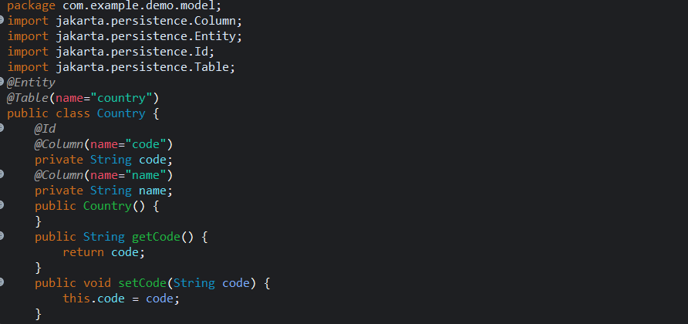
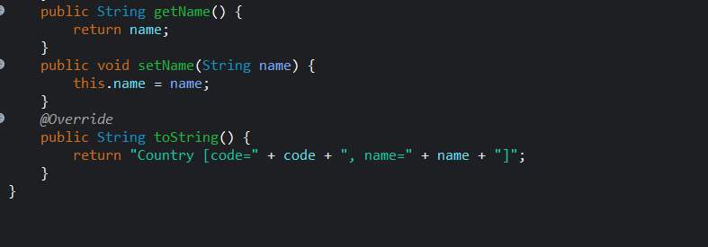
CountryRepository.java
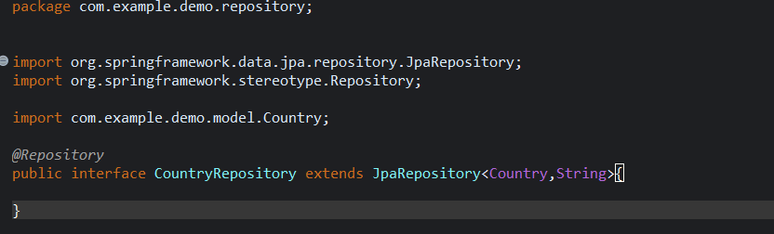
CountryService.java
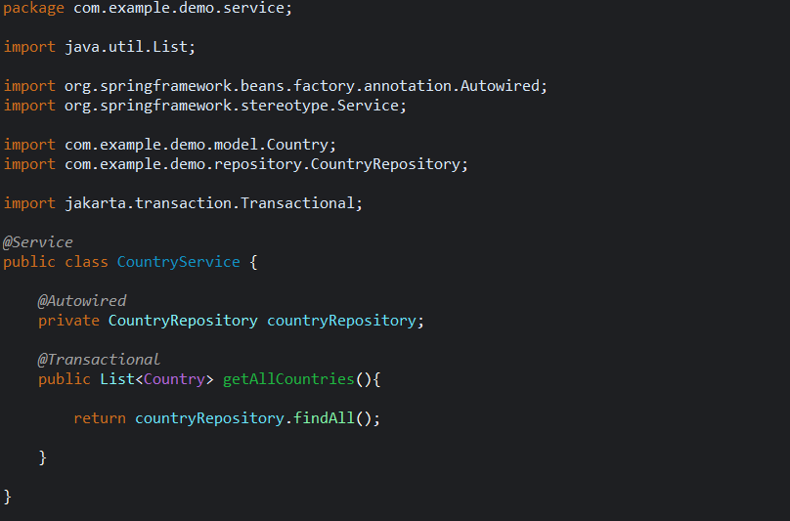
DemoApplication.java
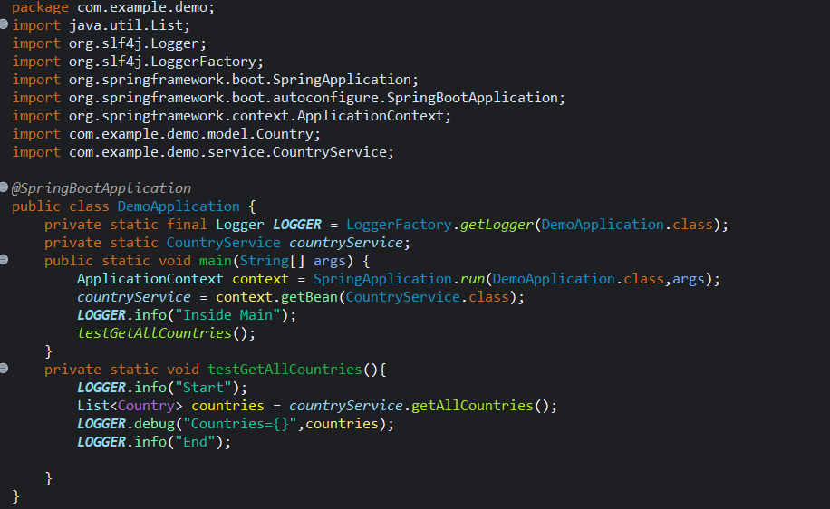

application.properties
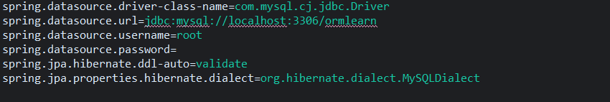

OUTPUT:
